AI-Driven Business Intelligence and Automated Customer Engagement Platform for SMEs

Overview
The developed system is an integrated web-based business intelligence platform designed specifically for small and medium enterprises (SMEs). It enables organizations to transform raw business data into actionable insights without requiring complex infrastructure, database integration, or specialized analytical expertise.
The platform combines analytics, artificial intelligence, forecasting, and automated communication within a unified environment. Both business owners and employees can securely access the system according to their roles and permissions.

Core Objectives
The system aims to:
- Democratize data analytics for small businesses
- Remove dependency on pre-configured databases
- Provide intelligent decision support
- Bridge the gap between analysis and action
- Enable non-technical users to operate advanced tools

User Roles (RBAC – Role Based Access Control)
Owner
The owner acts as administrator and decision authority. The owner can:
- Approve or reject employee registrations
- Remove employees
- View all datasets
- Delete datasets
- Approve offers created by employees
- Send campaigns directly
- View analytics history
- Chat with employees
Employee
Employees can:
- Upload and analyze datasets
- Ask questions
- Generate reports
- Create offers (subject to owner approval)
- Communicate internally
This ensures governance and operational security.

Data Ingestion & Processing
The system supports:
✔ CSV upload
✔ PDF upload
Upon upload, automated column detection identifies business fields such as:
- Sales
- Product
- Date
- Location
- Profit / Loss
Data is normalized and stored in MongoDB for analysis.

Analytics Engine
After processing, the platform generates:
- Total sales
- Profit and loss
- Average values
- Best and worst days
- Product performance
- City/territory performance
Visualization modules present:
- Line charts
- Bar graphs
- Pie / donut charts
- KPI cards
These dashboards provide quick managerial insight.

Forecasting Module
The forecasting mechanism uses trend-based heuristic extrapolation.
The model:
- Observes historical movement
- Detects growth direction
- Estimates future continuation
This approach is computationally lightweight and suitable for SMEs with limited historical data.

AI Interaction Layer
Two intelligence approaches are integrated:
Rule-Based Engine
Provides deterministic answers for:
- totals
- averages
- highest
- lowest
- trends
Ensures reliability and accuracy.
Generative AI
Used for:
- strategic advice
- explanation
- marketing suggestions
- campaign wording
This enhances interpretability and user friendliness.

Dataset Conversational Interface
Users can ask natural language questions such as:
- Which product is best?
- Where are sales low?
- What is average revenue?
- Is trend increasing?
The system interprets intent and produces answers based on computed analytics.

Customer Management
Users can build customer databases via:
- CSV upload
- PDF upload
- Manual entry
Information stored:
- name
- phone
- email
Data validation ensures incorrect formats are detected.
Owners can remove invalid contacts.

Festival & Smart Offer Suggestion
The system checks:
✔ today’s date
✔ known festivals
✔ upcoming events
If no current event exists, it recommends near-future campaigns.
This helps businesses plan promotions proactively.

Offer & Campaign System
Users create offers using:
- manual message writing
- AI-generated content from title
Workflow:
- If owner → send instantly
- If employee → requires approval
After approval, messages are automatically delivered to customers.

Communication Layer
The platform integrates:
- Email API
- SMS Gateway
It tracks:
✔ success
✔ failures
✔ counts
✔ resend capability
Thus providing measurable outreach.

Internal Communication
Owners and employees can chat within the platform, improving collaboration and reducing dependency on external tools.

Technology Stack
Frontend
- React.js
- Bootstrap
- Chart.js
- Framer Motion
Backend
- Node.js
- Express.js
Database
- MongoDB
AI Services
- Google Generative AI
Communication APIs
- Brevo (email)
- SMS gateway
Security
- JWT authentication
- bcrypt password hashing
- RBAC authorization

Key Innovations
The system uniquely provides:
✔ analytics without database connection
✔ hybrid AI
✔ built-in execution capability
✔ SME-friendly design
✔ approval governance
✔ automated marketing
Unlike enterprise BI tools, this platform focuses on simplicity + immediacy.

Impact
The solution helps businesses:
- reduce manual effort
- understand performance instantly
- identify opportunities
- respond faster
- improve revenue strategy

4.1 UML Diagram
- Use Case Diagram
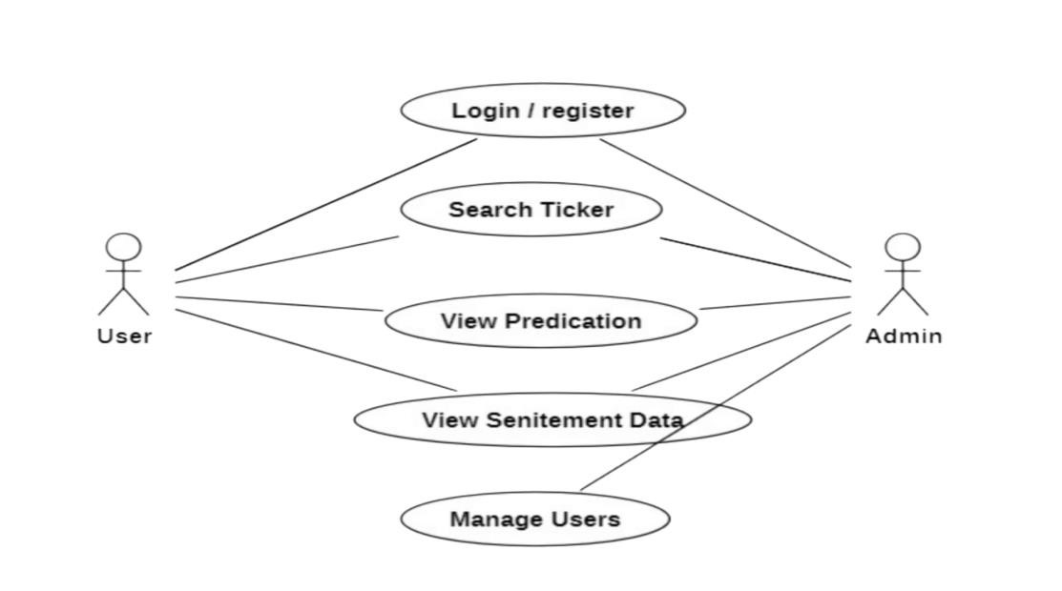

Fig 4.1 Use Case Diagram

- Data flow Diagram
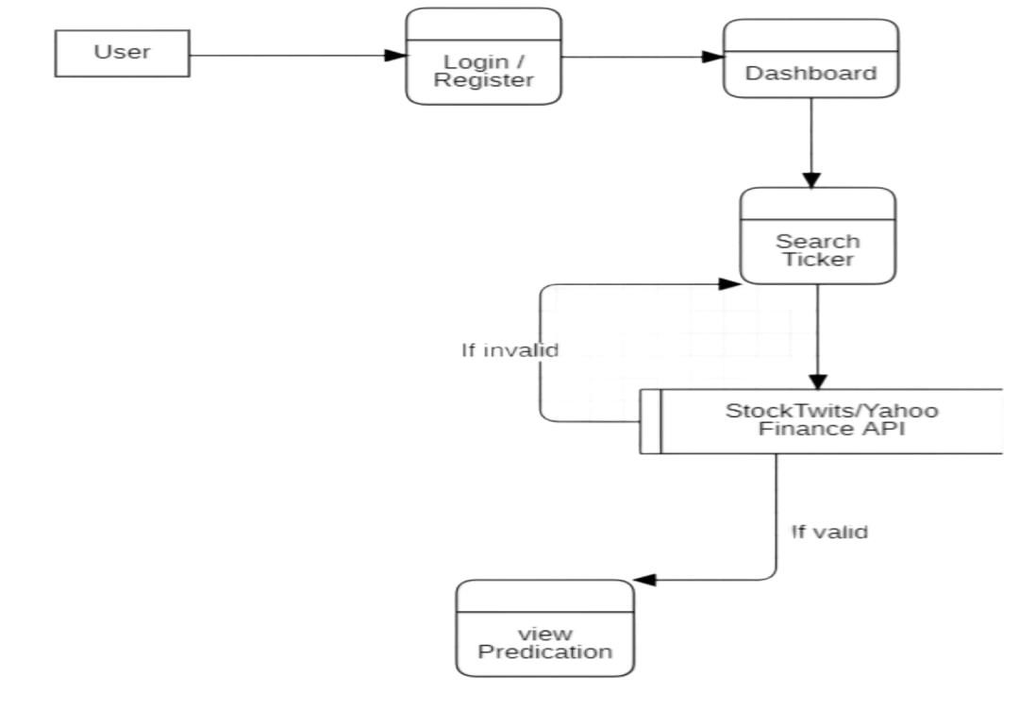
Fig.4.2 DataFLow Diagram

- Class diagram
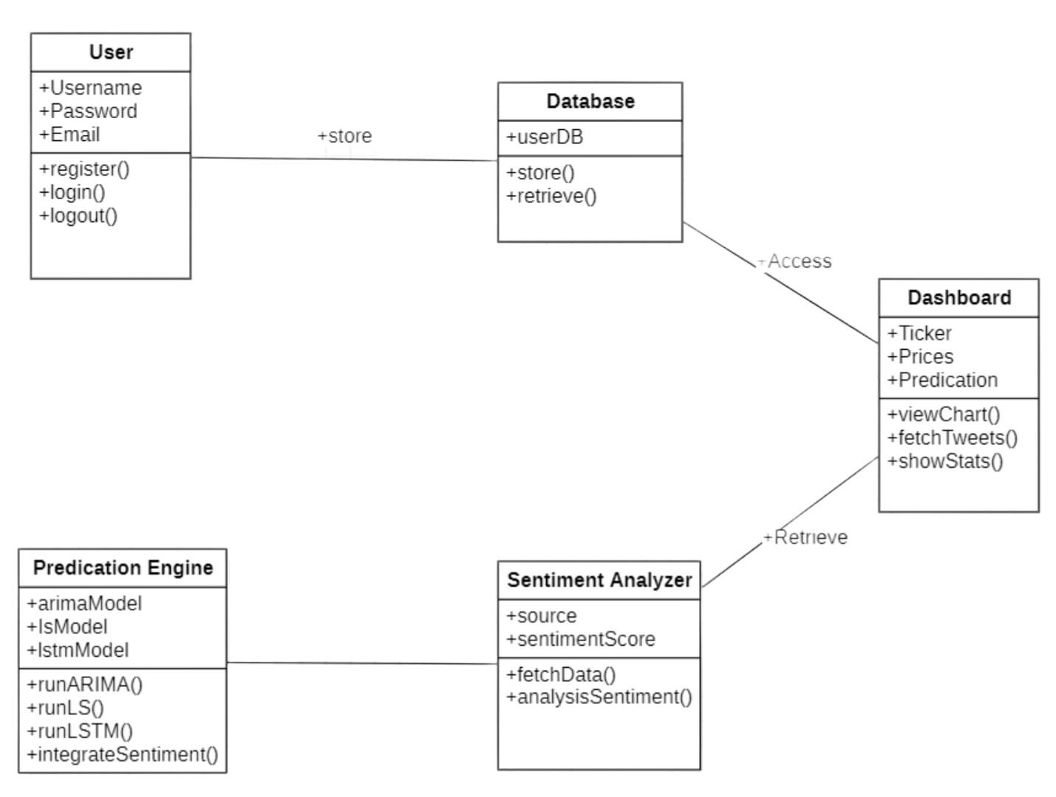

Fig 4.3 Class Diagram
- Entity Relationship Diagram
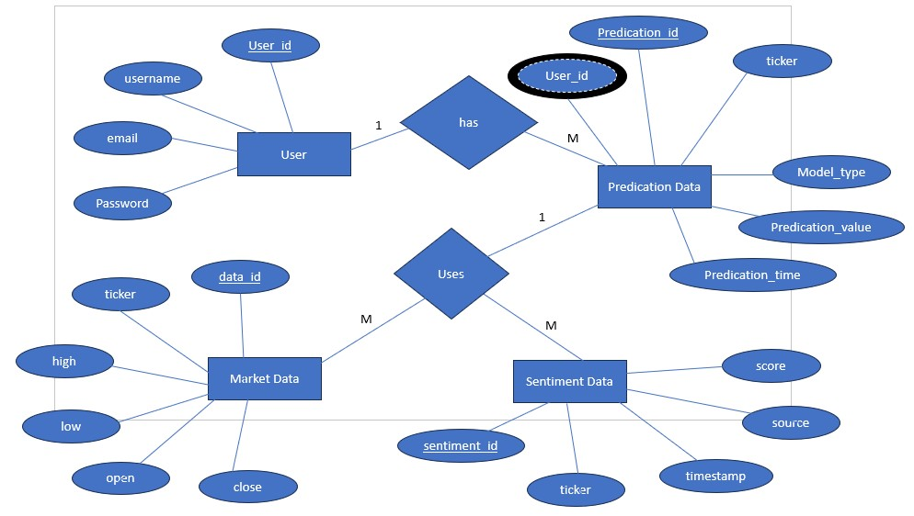
Fig 4.4 Entity Relationship

